Name : Lau Tee Ken (n9532897)

Personal Portfolio

I am TeeKen Lau, currently studying computer science. The project for my team 42 is Media Vault, which is the media storage website to handle and store relevant media files in different type includes song , video, pdf and picture. I will make brief important distribution on this web application project. The several of my contribution which uploading, downloading, deleting video and pdf files. The brief description for each contribution I have done towards the web application is shown at below and supporting document such as source code and acceptance testing is included within my folder named TeeKenLau (N9532897) in Git.

1.0 Video and pdf (Display)

The first contribution I had done is uploading and displaying the pdf and video in specific pages after the user has uploaded their files. I have written the code to link with database and display the specific files types in different categories of pages. The connection to database and storage is written in my source code to enable to display the information of media files. The users able to view the video directly from video pages without any video files download. The source code is available in my folder. The picture below is the interface and result of file types for the respective display page.

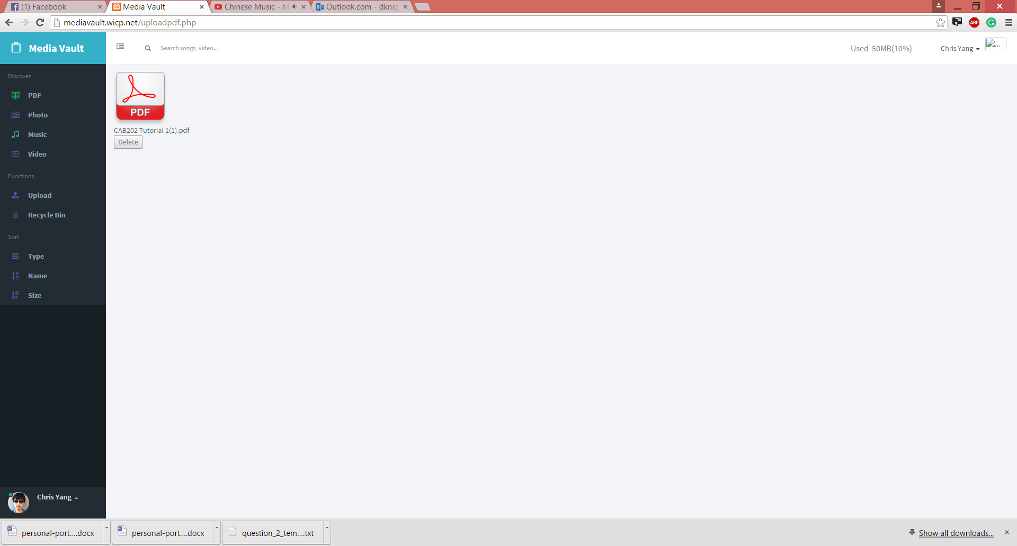

Figure 1.0 PDF display pages

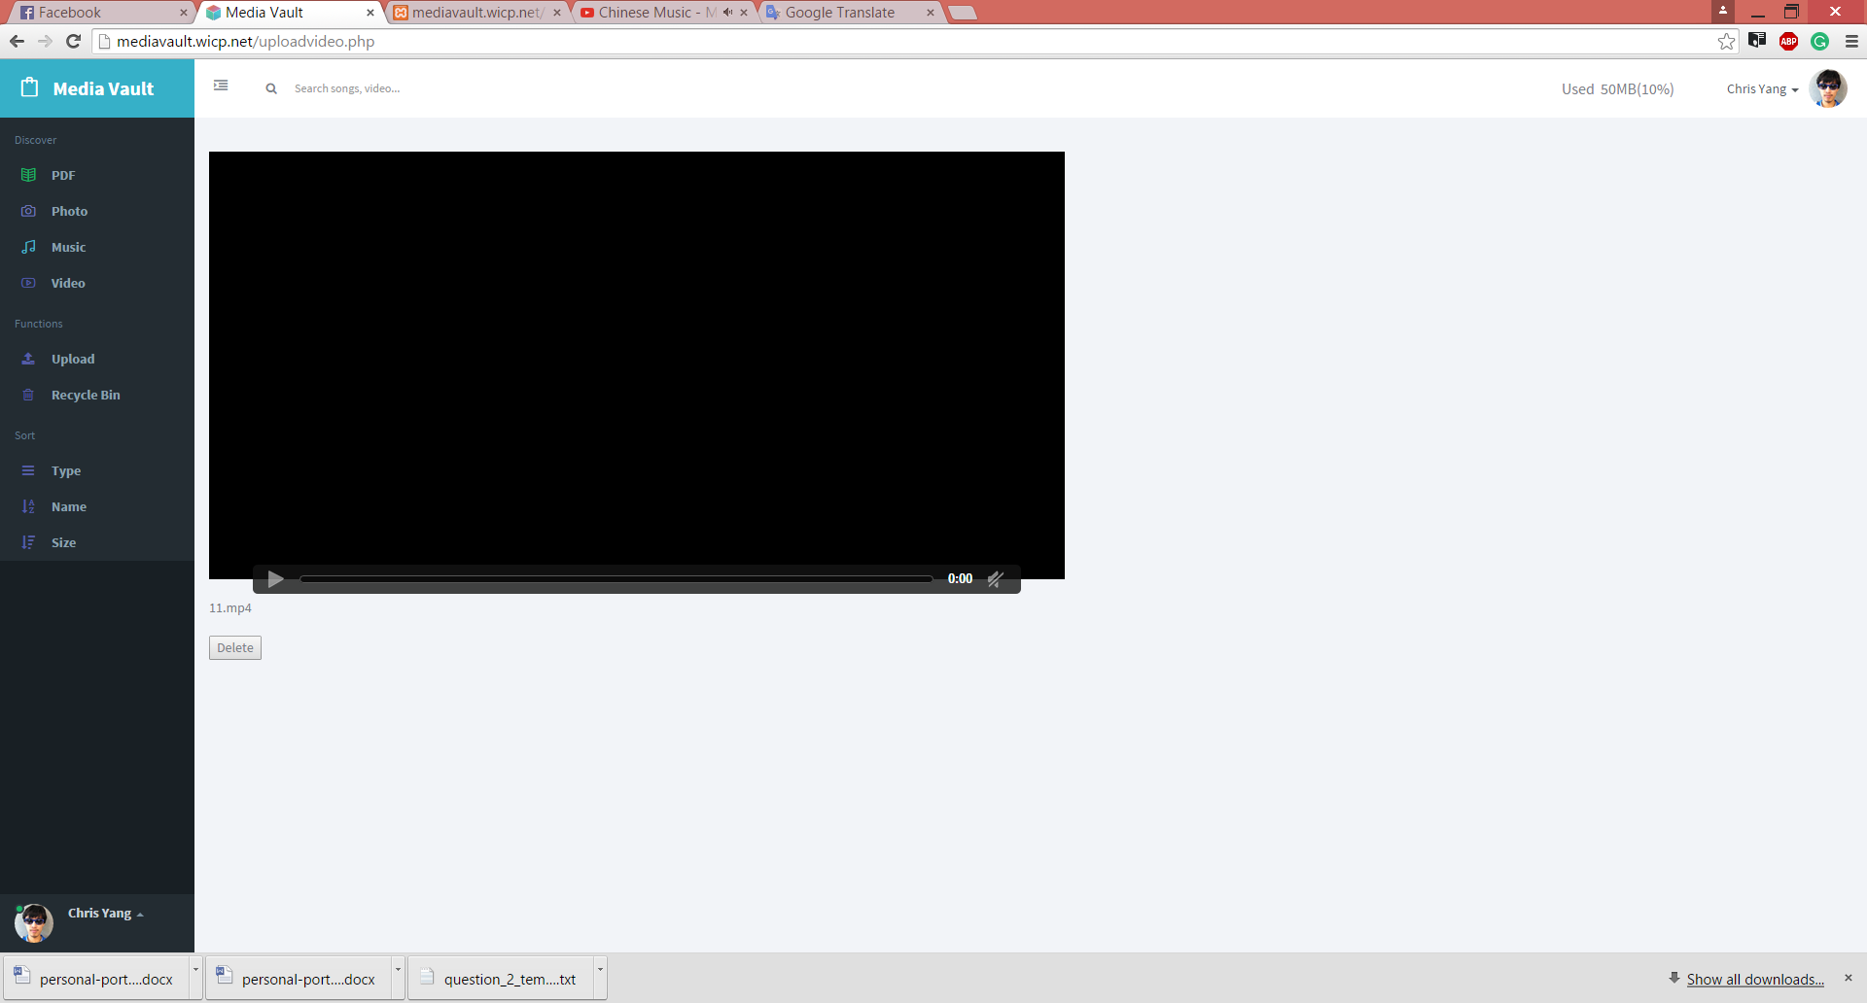

Figure 1.1 Video display pages

2.0 Video and pdf (Delete)

The second part of contribution on this project is to create function in order to delete unwanted media files in respective pages. I have done coding to link between database and web pages in order to display the information of media files before deleting files. Other than that, the web pages able to prompt the successful message on unwanted files have been deleted to inform users within javascript and php language in my source code.
The picture below is the output and result after the unwanted files have been deleted.

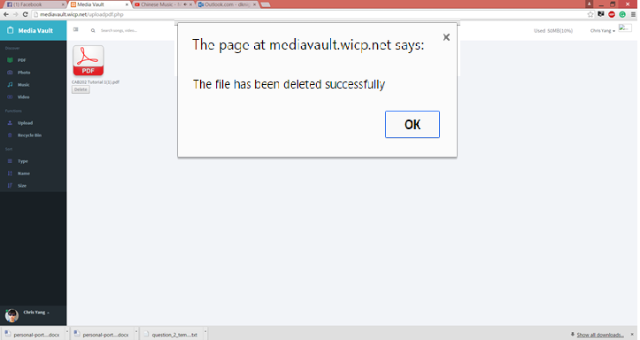

Figure 2.0 PDF files delete pages

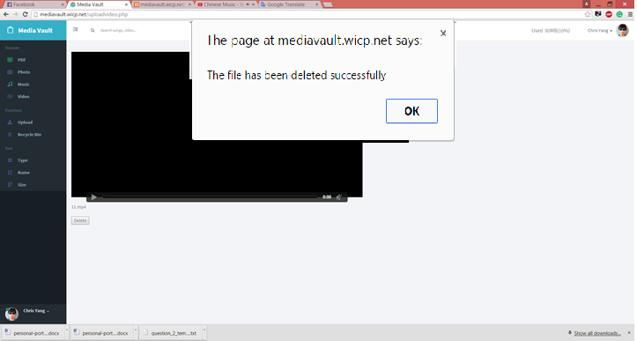

Figreu 2.1 Video files delete pages

3.0 Video and pdf (Upload)

The third distribution I have done is uploading function. The users able to choose the file types according the respective pages in order to upload the PDF and video files. I have written code to link the database and storage in order to save video files and PDF files to the storage of server and database. I have also written the source code to handle file type and file size error. The handling error is very important to restrict the users to upload file within maximum of file size and respective file types in order to make database and storage is stored in neat and flexbile manner. The picture below shows he result after the files have been uploaded by users according file types.

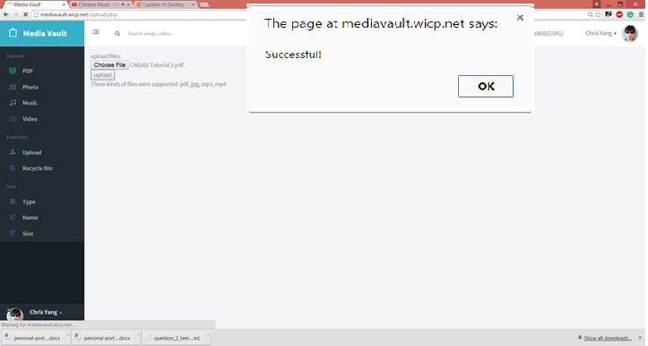

Figure 3.0 PDF files upload pages
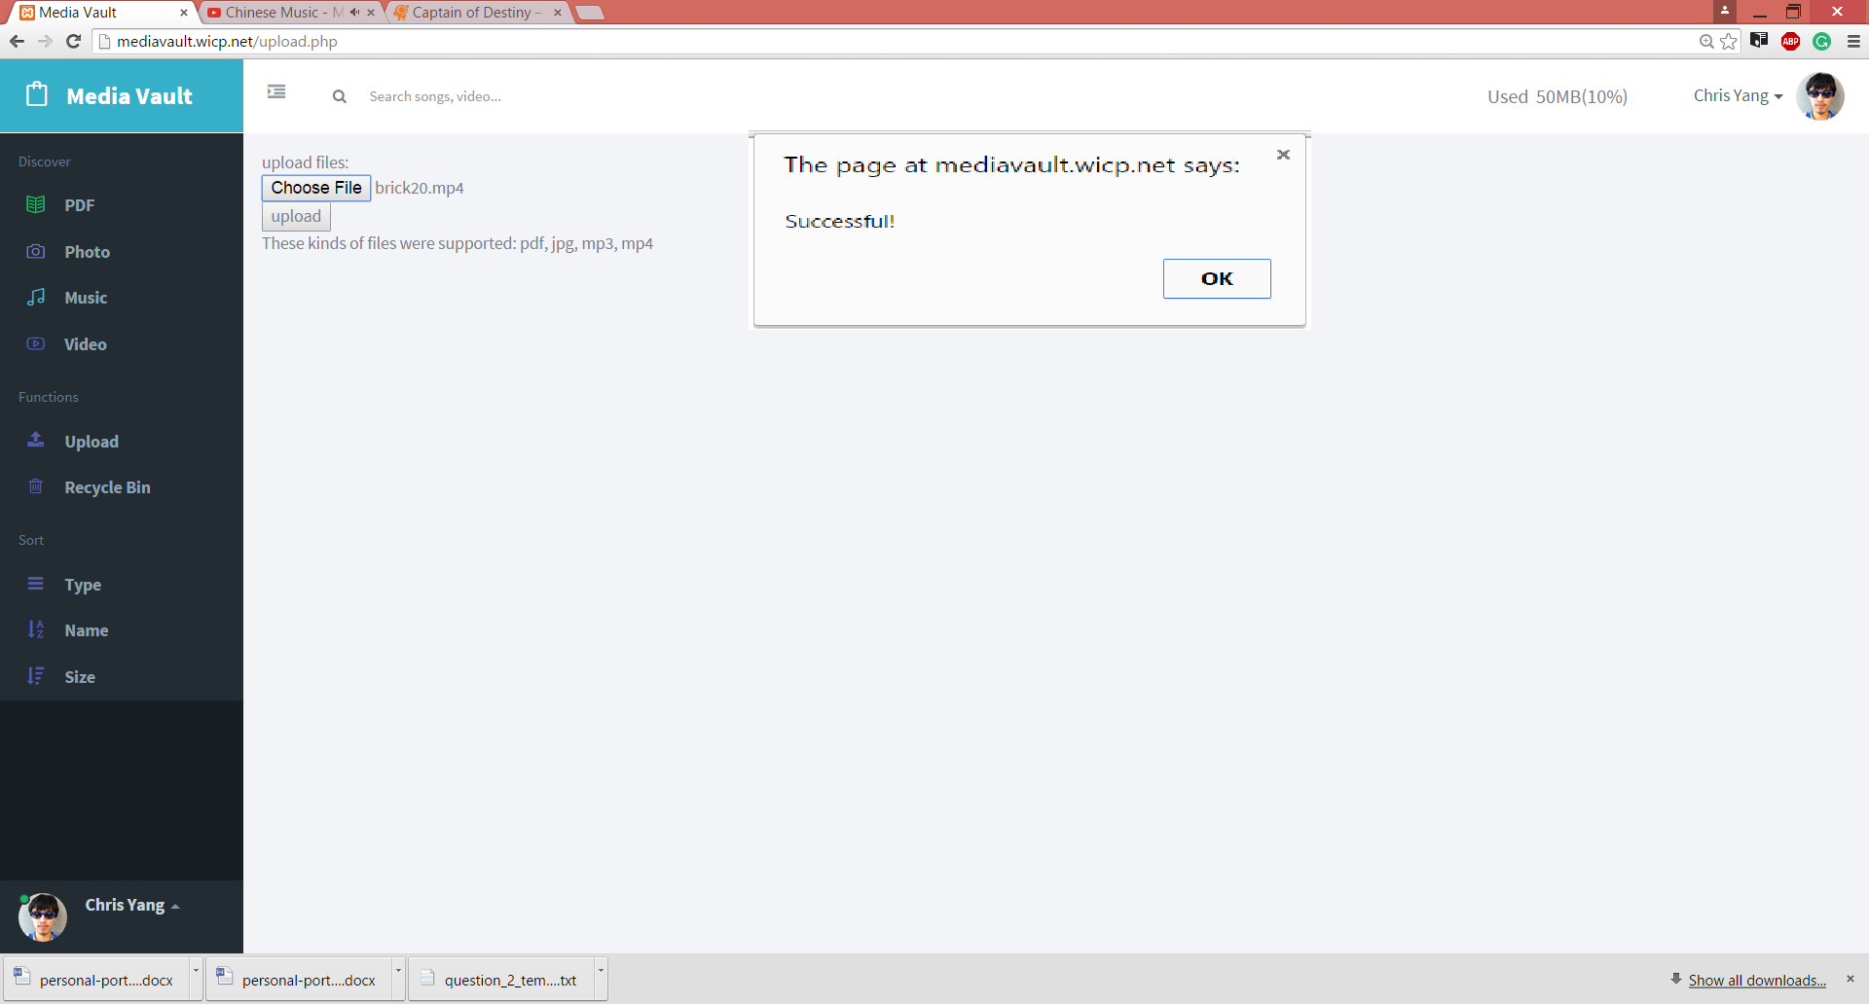

Figure 3.1 Video files upload pages

4.0 Searching testing

In addition, I have taken responsibility to implement important acceptance testing for searching function which is the most important in our web application project. The reason I choose to implement this acceptance testing in order to confirm it will not generate the duplicate files error from server and database which retrieves unwanted data and information for duplicate files from respective pages. The figure provided below shows the result of testing. As the figure shown below, there is one mistake which is test case not found within testing. I have discussed with my teammate and we have solved it already as we need to create a new case through recording what we have searched in our web application. Then, we have to implement the saved test case again to ensure there is not any file duplication error or command error is shown.

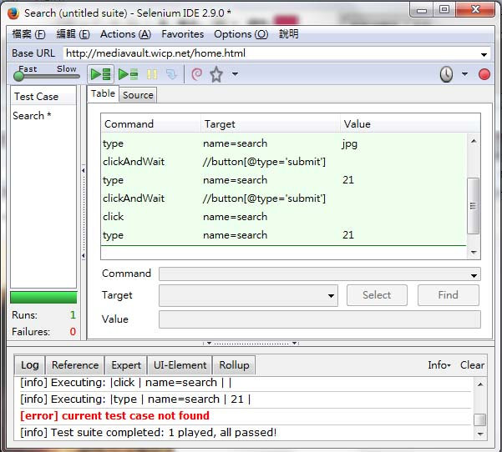

Figure 4.1 Search Acceptance Testing

5.0 Music Upload, Delete, Display testing
Last but not least, I have taken the acceptance testing which written by my teammate, Eric. The reason I choose the testing because I need to implement file testing in order to confirm it will not crash with data or information for respective file types such as PDF files, video files, music files which stored in database and server. The testing is taken as important steps to ensure our website is running smoothly at all time in the respective pages including uploading, displaying, deleting function of each files type according respective pages. The figure provided below demonstrates the outcome of acceptance testing. As the figure shown below, the test case is not found because the upload music files is just for displaying in Music pages and it is link with delete and display php files to handle the file deleting function.

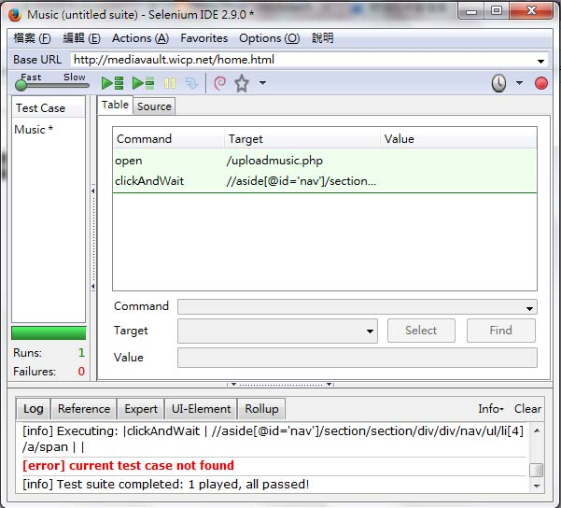

Figure 5.0 Music Uploading, Deleting, Display Testing

